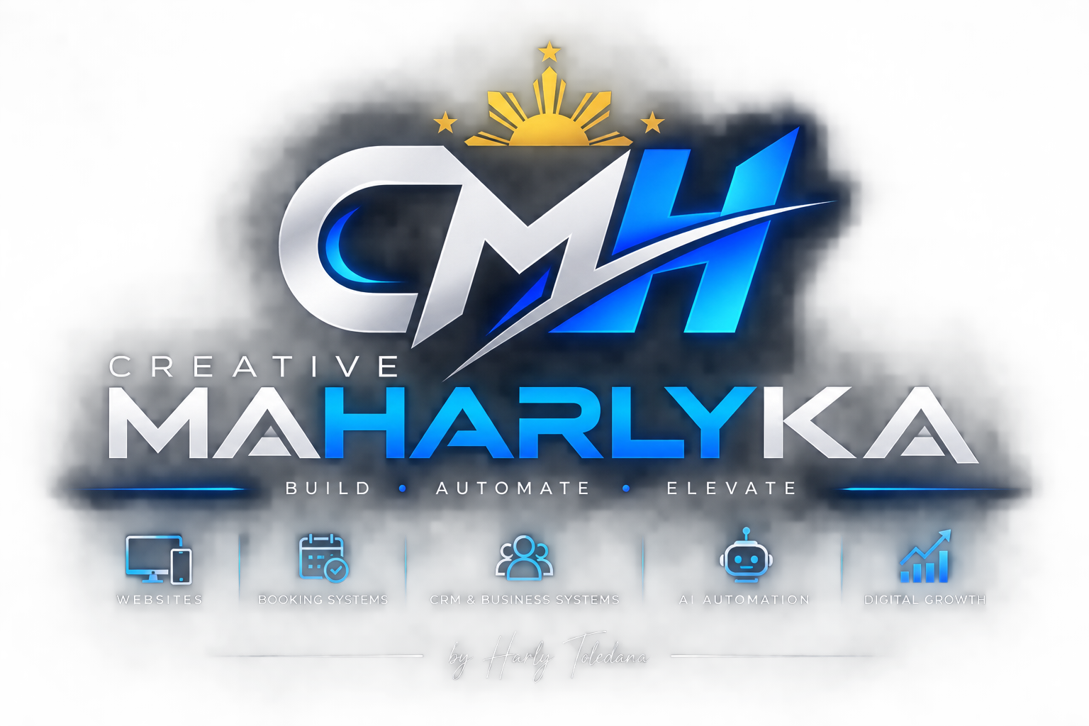
COMPANY PROFILE & PORTFOLIO
Websites • Booking Systems • CRM & Business Systems • AI Automation • Digital Growth
Creative Maharlyka builds practical digital systems that help growing businesses operate more efficiently — from customer-facing websites and booking experiences to internal CRM, operations tools, mobile workflows, and automation.
Founded & led by Harly Toledana • Tanza, Cavite, Philippines
facebook.com/creativemaharlyka

COMPANY PROFILE
Built around real business workflows.
We focus on practical systems that solve operational problems — not technology for technology’s sake. Every project starts with how the business actually works, then we design the simplest reliable system that can support it.
Business | Creative Maharlyka
Founder | Harly Toledana
Base | Tanza, Cavite, Philippines
Core Work | Websites, booking systems, CRM & business systems, AI automation, digital growth
Delivery Style | Custom, workflow-first, mobile-aware, production-focused
What we can build
Business Websites  Responsive business websites, landing pages, service sites, portfolios, and customer-facing information experiences. | Booking & Customer Portals  Online booking flows, customer accounts, status tracking, service history, saved details, support and self-service.
CRM & Operations Systems  Customer records, schedules, job workflows, staff assignment, dashboards, status tracking, audit-friendly operations. | Field / Mobile Workflows  Mobile-first technician or staff workflows, job status, inspections, evidence capture, notes, completion and handover.
AI & Automation  AI-assisted customer care, internal copilot workflows, content or process automation with deterministic business rules underneath. | Integrations & Growth  Payments, notifications, authentication, analytics, CRM integrations and digital growth support around the core system.
How we work
- Discover the actual workflow and must-have requirements before development.
- Define Version 1 clearly, separating essentials from future enhancements.
- Build with data ownership, security, access control, maintainability and handover in mind.
- Validate the system before release and document material changes, dependencies and agreed scope.

PORTFOLIO 01
HPToledana Enterprise
Our first featured client and flagship custom-system build: an integrated service-business ecosystem connecting customer acquisition, booking, operations, field service, payments, support, and ongoing customer care.
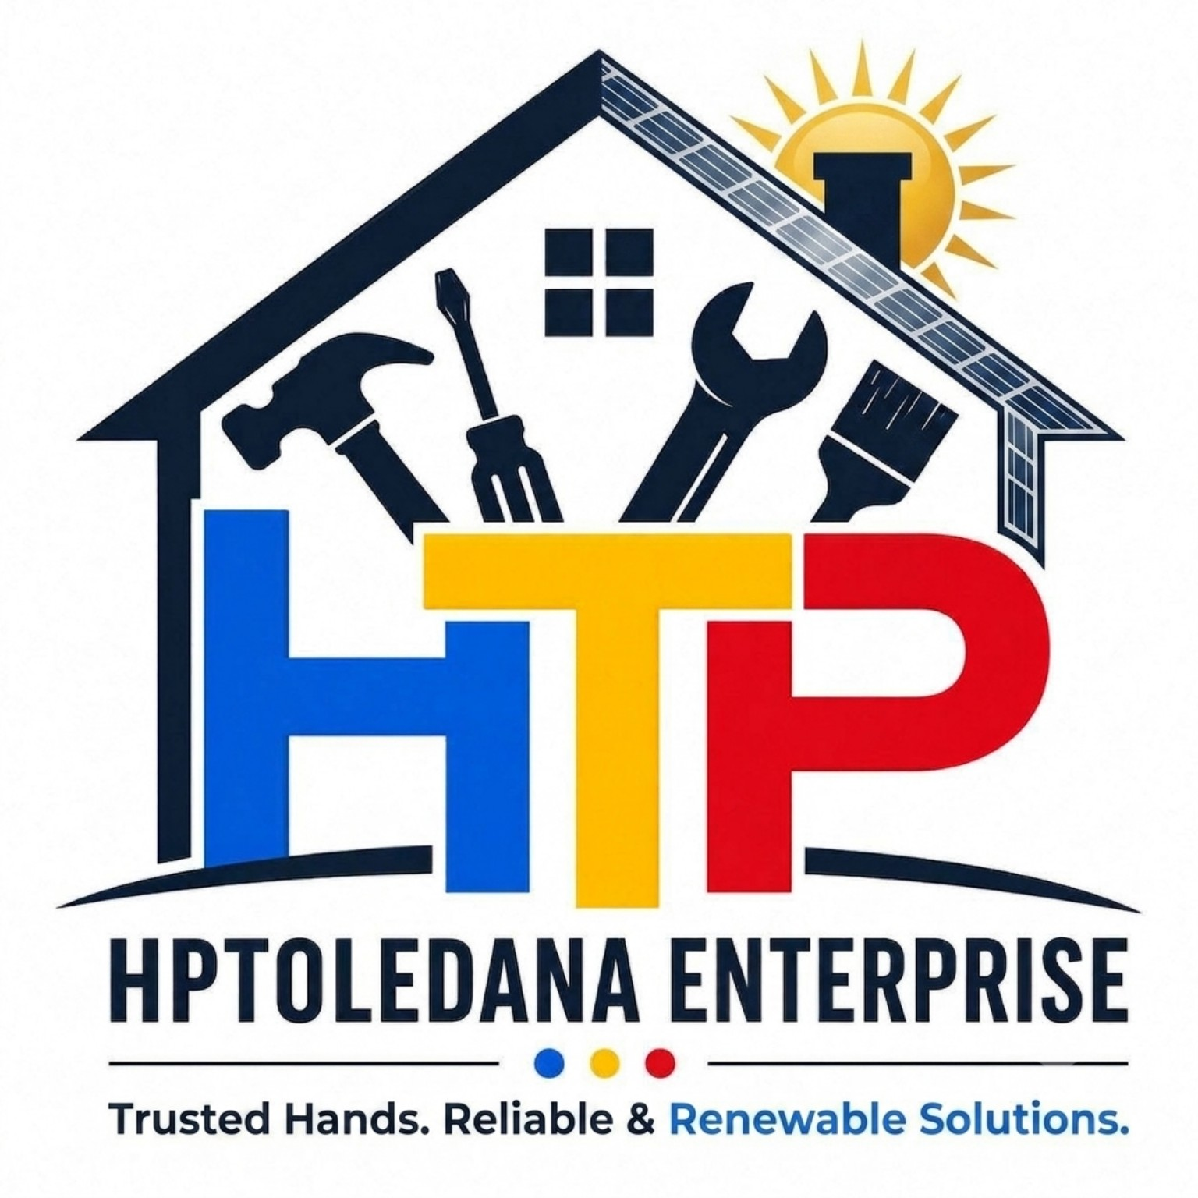 | Client  HPToledana Enterprise  Industry: Home services • Air conditioning • Solar & technical services  Public website: hptoledana.com
The business challenge
HPToledana needed more than a brochure website. The goal evolved into one connected operating system that could serve customers, office staff and field Pros while keeping booking, unit/service records, payment status, evidence and support aligned across channels.
What Creative Maharlyka built
Public Website + Booking  Responsive website with service presentation and a structured multi-step online booking journey. | Customer Portal PWA  Customer self-service for bookings, properties/units, history, payments, rewards, help and support.
HPToledana OS  Central operations system for customers, bookings, job orders, service catalog, staff/Pro administration, support, finance and diagnostics. | HPT Pro Android App  Field-service workflow for assigned jobs, arrival/status, inspections, photos/evidence, materials, service progression, messaging and completion.
Shared Backend & Automation  Authoritative database, APIs/RPCs, access policies, storage, notifications, payment webhooks and workflow automation. | AI-Assisted Workflows  Toley-assisted customer and operational experiences, designed to work with authoritative business data and guarded actions.

HPTOLEDANA CASE STUDY
One ecosystem, multiple user experiences.
The project demonstrates Creative Maharlyka’s ability to connect customer-facing experiences, back-office operations and mobile field workflows to one shared business process.
CUSTOMER  Website + Customer Portal  Booking • Account • Units • Payments • Support | OPERATIONS  HPToledana OS  CRM • Bookings • Job Orders • Dispatch • Finance • Support
FIELD TEAM  HPT Pro Android App  Assigned Jobs • Inspections • Evidence • Materials • Completion | SHARED CORE  Backend + Automation  Authoritative records • Permissions • Notifications • Payment events • Audit
Selected capabilities delivered
- Unit-first booking and service-line tracking across customer, operations and field-service surfaces.
- Customer identity, property and equipment records with reusable service history.
- Scheduling, job status progression, field evidence, inspections, service completion and reporting workflows.
- Role-aware access controls, private storage rules, operational diagnostics and audited sensitive actions.
- Payment-gateway checkout/webhook workflows and controlled payment-state handling.
- Customer/Pro/Operations communication, notifications and support workflows.
- Production deployment across Cloudflare-hosted web applications plus Android release workflows and backend services.
Technology & delivery foundation
Frontend  React / Vite | Backend  Supabase / PostgreSQL | Hosting  Cloudflare Pages / Workers | Mobile & Push  Android / Capacitor / Firebase

SELECTED INTERFACE WORK
Actual project views, presented without confidential customer data.
These screens illustrate the breadth of the HPToledana implementation. Customer records and other sensitive details are intentionally excluded from this portfolio document.
Public Website — structured service booking
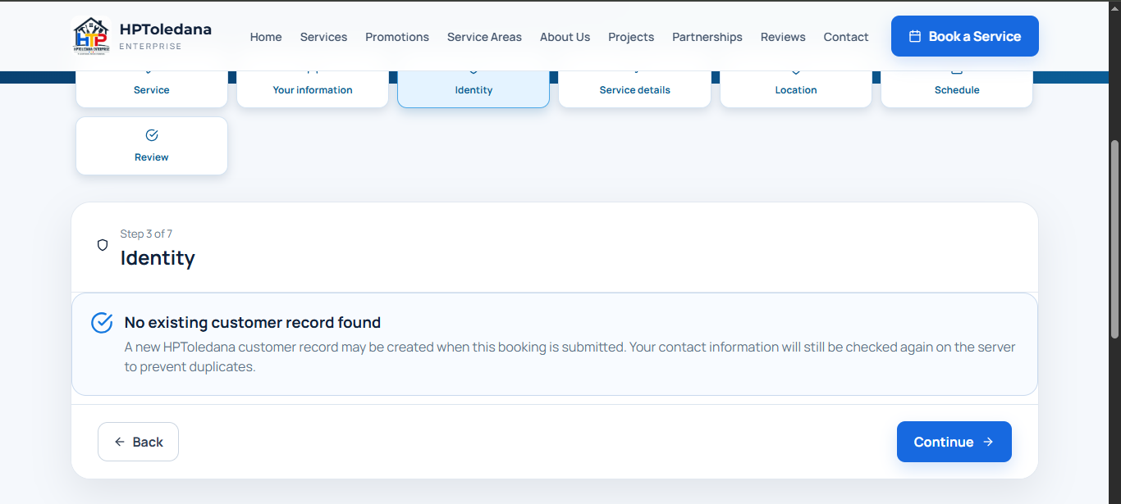
A responsive, step-based booking experience designed to keep customer identity, service details, location, schedule and review stages clear.
HPToledana OS — centralized operations
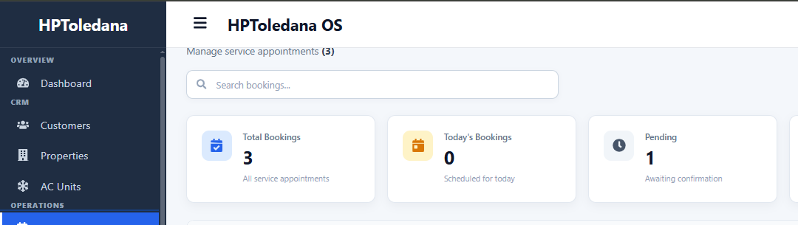
Operations dashboard architecture spanning CRM, properties/units, bookings, job orders, follow-ups, access documents, technicians and support.

SELECTED INTERFACE WORK
HPT Pro — mobile field-service workflow.
The field app turns an assigned job into a guided operational process, helping technicians capture the right service evidence and progress through the job consistently.
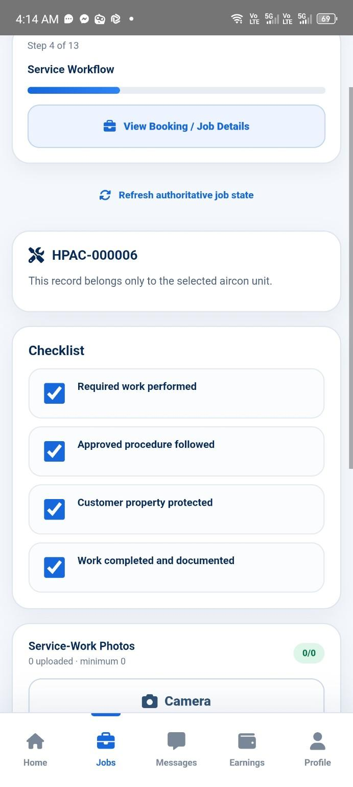 | Field workflow capabilities  - Assigned-job progression and status updates  - Pre-service / service / post-service checkpoints  - Photo and evidence capture tied to the correct unit/service line  - Materials and service-work recording  - Booking-linked communication and payment/completion flow  - Mobile-first interface designed for field use
Why this project matters
HPToledana demonstrates our workflow-first approach: one connected system for customer acquisition, booking, CRM, operations, field execution, payments, support and automation, with shared business rules and access controls.
LET’S BUILD A SYSTEM AROUND YOUR WORKFLOW.
Start with a short discovery conversation, then define a practical Version 1 scope for your website, booking, CRM, mobile workflow or automation project.
Harly Toledana • Creative Maharlyka • Tanza, Cavite, Philippines
facebook.com/creativemaharlyka

